Handout 1
C++ Programming
Deadline September 28

Exercise 1
Given the following assignment of variables to values:
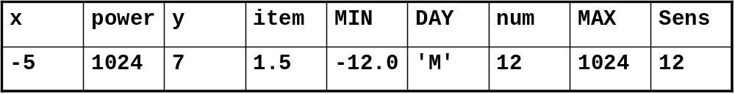

Fill in the result values of the conditions in the table below:

Condition | Result
(x>y) && !y | 0 (False)
(item>MIN)||(DAY!=’M’) | 1 (True)
((num*128)<power)&&y | 0 (False)
(!(power!=MAX))&&(Sens==num) | 1 (True)
((y+x)<num)||(DAY==’M’) | 1 (True)
(Sens*(!y))!=0 | 0 (False)
(!x||y)&&(!y||x) | 1 (True)

Exercise 2
Write a program in C++ that performs the following tasks:
- Read three integer values using cin.
- Determine the maximum of the three values entered by the user.
- Print the maximum of this three values using cout.

Exercise 3
Write a program that asks the user to type numbers. After each entry, the program should report the cumulative sum of the entries. The program should terminate when the user enters 0.

Exercise 4
Create a program to determine the GCD (Greatest Common Divisor) of two integers x and y using a ‘while loop’.

Formal description of the Euclidean algorithm
- Input Two positive integers, a and b.
- Output The greatest common divisor, g, of a and b.
- Internal computation
  - If a<b, exchange a and b.
  - Divide a by b and get the remainder, r.
If r=0, report b as the GCD of a and b.
  - Replace a by b and replace b by r. Return to the previous step.

